Bias Variance Trade-off

Bias: The inability of ML Model to Truly capture the relation in training model.
Variance : The Variance is difference of fit on different datasets
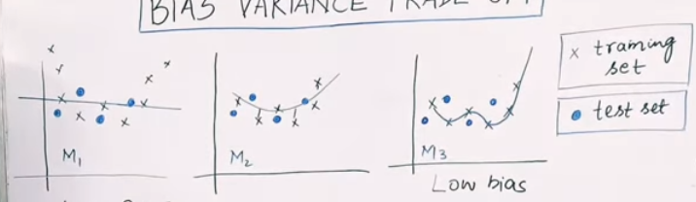
High Bias

Training mai aapka error aaya 100

Test – Training data = Variance
If training mai 10 ka error hai & testing mai 100
Then 100-10 = 90 high variance hai or high variability hai

Training data pe dependent hogya tou overfitting

Bias Variance Tradeoff - Clearly Explained | Machine Learning Plus
https://www.machinelearningplus.com/machine-learning/bias-variance-tradeoff/

